Project Word Document

Many of my friends like working out, but one thing that’s important with the gym is consistency, so what I’ve decided to set out to create is a simple workout tracker tool. Using this website you can submit your workouts and track them so you can make sure to not repeat the same exercises too frequently.

The first part of the project is the splash page, which will include a title at the top, a footer with my copyright and a simple login section. For now however the plan is to simply include a form where you can input your workouts. That way you can immediately add what you’re working on right from the get-go.

The second component is of course the output, which I want displayed on a second page, this second page will still carry the same header and footer as the splash page, but will focus on displaying the stored data in a chart.

Finally, I plan on integrating mongoDB and a cloud service, (Probably Heroku) to store the data and host online!
.

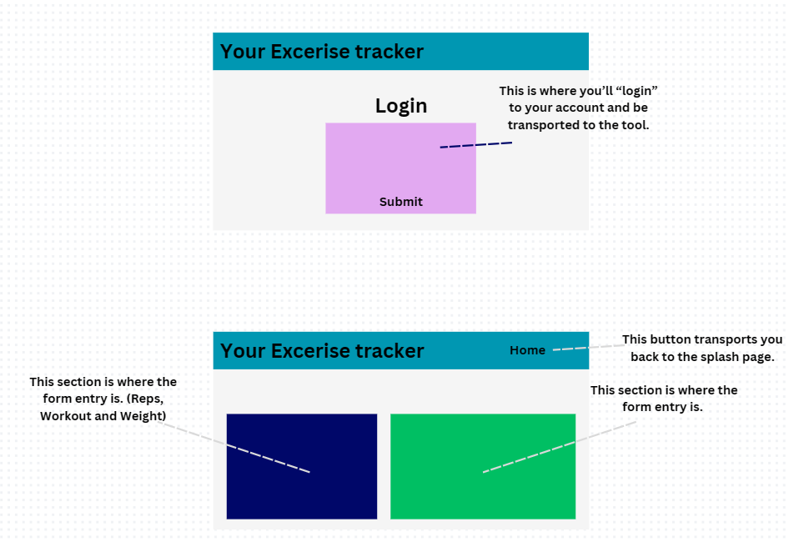

Thank you for reading :)

